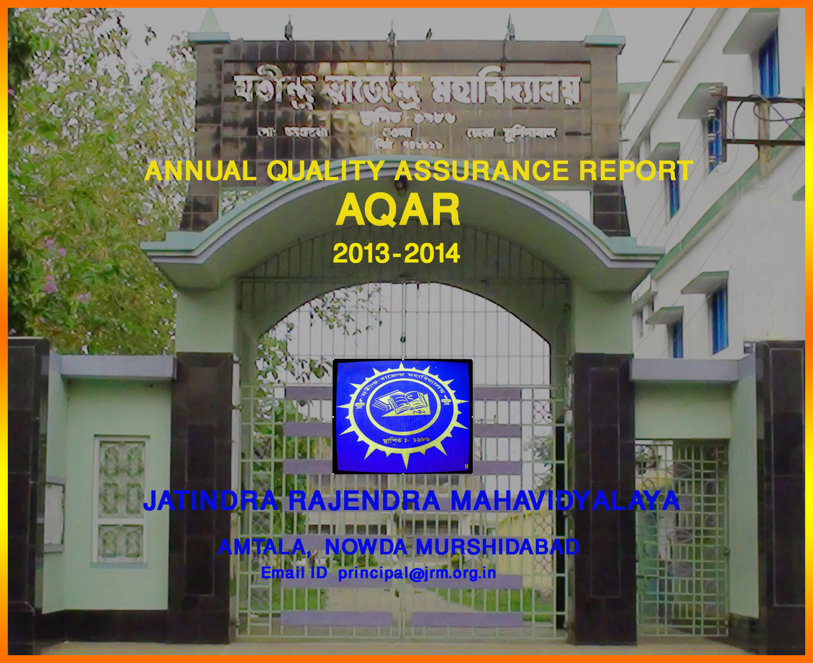The Annual Quality Assurance Report (AQAR) of the IQAC

All NAAC accredited institutions will submit an annual self-reviewed progress report to NAAC, through its IQAC. The report is to detail the tangible results achieved in key areas, specifically identified by the institutional IQAC at the beginning of the academic year. The AQAR will detail the results of the perspective plan worked out by the IQAC. (Note: The AQAR period would be the Academic Year. For example, July 1, 2012 to June 30, 2013)

Part – A
2013-14
AQAR for the year (for example 2013-14)

1. Details of the Institution
Jatindra Rajendra Mahavidyalaya
1.1 Name of the Institution
P 0 - AMTALA
1.2 Address Line 1
DIST - MURSHIDABAD
Address Line 2
AMTALA
City/Town
WEST BENGAL
State
742121
Pin Code
principal@jrm.org.in

Institution e-mail address
03482 -247244 & 03482 – 247107.
Contact Nos.
GEETALI BERA
Name of the Head of the Institution:
03482 - 247905
Tel. No. with STD Code:
09434687179
Mobile:
SUCHARITA MITRA
Name of the IQAC Co-ordinator:
09732656465
Mobile:
sucharitamitra22@gmail.com
IQAC e-mail address:

WBCOXX13314
1.3 NAAC Track ID (For ex. MHCOGN 18879)
OR

1.4 NAAC Executive Committee No. & Date:
March 31, 2007/241
(For Example EC/32/A&A/143 dated 3-5-2004.
This EC no. is available in the right corner- bottom
of your institution’s Accreditation Certificate)

1.5 Website address:
www.jrm.org.in

Web-link of the AQAR: http:// www.jrm.org.in /AQAR2013-14.doc

1.6 Accreditation Details
Sl. No. | Cycle | Grade | CGPA | Year of Accreditation | Validity Period
1 | 1st Cycle | C++ |  | 2007 | 5
2 | 2nd Cycle
3 | 3rd Cycle
4 | 4th Cycle

1.7 Date of Establishment of IQAC : DD/MM/YYYY
29.01.2014

1.8 Details of the previous year’s AQAR submitted to NAAC after the latest Assessment and Accreditation by NAAC ((for example AQAR 2010-11submitted to NAAC on 12-10-2011)
- AQAR _______________________ __________________ (DD/MM/YYYY)4
- AQAR__________________ ________________________ (DD/MM/YYYY)
- AQAR__________________ _______________________ (DD/MM/YYYY)
- AQAR__________________ _______________________ (DD/MM/YYYY)
1.9 Institutional Status
√√

University State Central Deemed Private

Affiliated College Yes No
√
Constituent College Yes No

Autonomous college of UGC Yes No

Regulatory Agency approved Institution Yes No
(eg. AICTE, BCI, MCI, PCI, NCI)
√

Type of Institution Co-education Men Women

Urban Rural Tribal

Financial Status Grant-in-aid UGC 2(f) UGC 12B

Grant-in-aid + Self Financing Totally Self-financing

1.10 Type of Faculty/Programme

Arts Science Commerce Law PEI (Phys Edu)

TEI (Edu) Engineering Health Science Management

Others (Specify)

1.11 Name of the Affiliating University (for the Colleges)
UNIVERSITY OF KALYANI

1.12 Special status conferred by Central/ State Government-- UGC/CSIR/DST/DBT/ICMR etc NA

Autonomy by State/Central Govt. / University

University with Potential for Excellence UGC-CPE

DST Star Scheme UGC-CE

UGC-Special Assistance Programme DST-FIST

UGC-Innovative PG programmes Any other (Specify)

UGC-COP Programmes
2. IQAC Composition and Activities
7
2.1 No. of Teachers
2
2.2 No. of Administrative/Technical staff
0
2.3 No. of students
2.4 No. of Management representatives
Nil
2
2.5 No. of Alumni
2. 6 No. of any other stakeholder and
Nil
community representatives
1
2.7 No. of Employers/ Industrialists
1
2.8 No. of other External Experts
2.9 Total No. of members
13
2.10 No. of IQAC meetings held

2.11 No. of meetings with various stakeholders: No. Faculty

Non-Teaching Staff Students Alumni Others

√

2.12 Has IQAC received any funding from UGC during the year? Yes No

If yes, mention the amount
2.13 Seminars and Conferences (only quality related)
(i) No. of Seminars/Conferences/ Workshops/Symposia organized by the IQAC

5
Total Nos. International National State Institution Level

(ii) Themes

2.14 Significant Activities and contributions made by IQAC
- The College administration oversees issues of quality management in the various aspects of the Institution as the IQAC has not been established officially. The Institutional administration plans for a range of academic and Non-academic activities.
- Block B ground floor construction of college completed and inaugurated.
- Installation of additional 13 CCTVs at significant points all over college campus.
- Equipment for classroom teaching as well as smooth office functioning purchased.
- Remedial classes taken for weaker students.
- Students’ Cooperative Fund created to facilitate purchase of necessary items for students.
- Organised programmes on Youth for Mass Literacy and AIDS Day Observation (3.12.14).
- Continued to encourage the staff to register/complete Minor Research Projects and Ph.D.

2.15 Plan of Action by IQAC/Outcome
The plan of action chalked out by the IQAC in the beginning of the year towards quality
enhancement and the outcome achieved by the end of the year *

Plan of Action | Achievements
- Bringing extra dimension to classroom teaching through purchase of adequate equipment  - Bringing entire college campus under CCTV supervision  - Stimulating teaching faculty to improve themselves through Orientation and Refresher Courses.  - Organising seminars/workshops for training purposes  - Block B ground floor construction was planned to be completed.  - Students’ Cooperative Fund was planned to be created to facilitate purchase of necessary items for students.  - Remedial Coaching was planned to be arranged for weaker students of the college | Adequate fans, chairs, blackboards were purchased to help classroom experience be comfortable and enriching for students.  13 additional CCTVs were installed at significant locations to oversee activities of staff and students and avert any objectionable action.  Teachers were sent for Orientation and Refresher Courses for self-improvement.  Departments held mini-seminars with batches of students keeping in mind current topics within curriculum relevant to students’ understanding of subjects taught and to understand their way of interpreting the texts.  Block B ground floor construction was completed and inaugurated for use by staff and students.  Students’ Cooperative Fund was made to enable purchase of necessary items for students.  From 2.01.14 to 30.04.14, remedial classes were organised and taken by faculty to bring weaker students at par with the rest of the class.

* Attach the Academic Calendar of the year as Annexure.
√

2.15 Whether the AQAR was placed in statutory body Yes No

Management Syndicate Any other body
Provide the details of the action taken
Plan:
- Bringing extra dimension to classroom teaching through purchase of adequate equipment
- Bringing entire college campus under CCTV supervision
- Stimulating teaching faculty to improve themselves through Orientation and Refresher Courses
- Organising seminars/workshops for training purposes
- Block B ground floor construction was planned to be completed
Achievements:
Adequate benches, chairs, blackboards were purchased to help classroom experience be comfortable and enriching for students.
13 additional CCTVs were installed at significant locations to oversee activities of staff and students and avert any objectionable action.
Teachers were sent for Orientation and Refresher Courses for self-improvement.
Departments held seminars with batches of students keeping in mind current topics within curriculum relevant to students’ understanding of subjects taught and to understand their way of interpreting the texts.
Block B ground floor construction was completed and inaugurated for use by staff and students.

Block B ground floor construction was completed and inaugurated for use by staff and students.

Part – B

Criterion – I

1. Curricular Aspects
1.1 Details about Academic Programmes
Level of the Programme | Number of existing Programmes | Number of programmes added during the year | Number of self-financing programmes | Number of value added / Career Oriented programmes
PhD
PG
UG | 12
PG Diploma
Advanced Diploma
Diploma
Certificate
Others
Total | 12

Interdisciplinary
Innovative

1.2 (i) Flexibility of the Curriculum: CBCS/Core/Elective option / Open options
(ii) Pattern of programmes:
Pattern | Number of programmes
Semester
Trimester
Annual | 12

1.3 Feedback from stakeholders* Alumni Parents Employers Students
(On all aspects)

Mode of feedback : Online Manual Co-operating schools (for PEI)

1.4 Whether there is any revision/update of regulation or syllabi, if yes, mention their salient aspects.
N/A

1.5 Any new Department/Centre introduced during the year. If yes, give details.
N/A

Criterion – II
2. Teaching, Learning and Evaluation
2.1 Total No. of permanent faculty
Total | Asst. Professors | Associate Professors | Professors | Others
18 | 4 | 1 |  | 1(CWTT) 12(APTT)

2.2 No. of permanent faculty with Ph.D.
1
2.3 No. of Faculty Positions Recruited (R) and Vacant (V) during the year
Asst. Professors |  | Associate Professors |  | Professors |  | Others |  | Total
R | V | R | V | R | V | R | V | R | V

09 -UG
2.4 No. of Guest and Visiting faculty and Temporary faculty
2.5 Faculty participation in conferences and symposia:

No. of Faculty | International level | National level | State level
Attended Seminars/ Workshops |  |  | 6
Presented papers |  |  | 6
Resource Persons

2.6 Innovative processes adopted by the institution in Teaching and Learning:

- System of Group discussions for advanced learners was implemented in the classrooms.
- Use of charts and internet based resources was facilitated for better understanding.
- Internal paper reading and students’ own understanding of text taught in class was encouraged through participation in departmental seminars.
- Home assignments given to weaker students to help their grasp of subject.

2.7 Total No. of actual teaching days
157
during this academic year
Regular class tests, MCQ and cross- evaluation methods were used.
2.8 Examination/ Evaluation Reforms initiated by
the Institution (for example: Open Book Examination, Bar Coding,
Double Valuation, Photocopy, Online Multiple Choice Questions)

0
1
0
2.9 No. of faculty members involved in curriculum
restructuring / revision / syllabus development
as member of Board of Study/Faculty/Curriculum Development workshop
68
2.10 Average percentage of attendance of students

2.11 Course/Programme wise
distribution of pass percentage :

Title of the Programme | Total no. of students appeared | Division
Title of the Programme | Total no. of students appeared | Distinction % | I % | II % | III % | Pass %
B.A.(Hons) | 144 | N/A | 16 | 74 | N/A | N/A
B.A (Gen) | 128 | N/A | Nil | 13 | N/A | 43

2.12 How does IQAC Contribute/Monitor/Evaluate the Teaching & Learning processes:
IQAC was not officially established yet. The College Administration monitors/evaluates the teaching and learning process by
- Conducting periodical meetings.
- Planning examination timetable, teaching days and holidays.
- Encouraging workshops/ training programmes for teaching faculty.

2.13 Initiatives undertaken towards faculty development Nil
Faculty / Staff Development Programmes | Number of faculty  benefitted
Refresher courses
UGC – Faculty Improvement Programme
HRD programmes
Orientation programmes | 02
Faculty exchange programme
Staff training conducted by the university
Staff training conducted by other institutions
Summer / Winter schools, Workshops, etc.
Others

2.14 Details of Administrative and Technical staff
Category | Number of Permanent  Employees | Number of Vacant  Positions | Number of permanent positions filled during the Year | Number of positions filled temporarily
Administrative Staff | 11 | 03 | 00 | 00
Technical Staff | 01 | 00 | 00 | 00

Criterion – III
3. Research, Consultancy and Extension
3.1 Initiatives of the IQAC in Sensitizing/Promoting Research Climate in the institution

- The college induces the teachers to write research papers on different subjects.
- Reprographic facilities provided for teachers in Teaching Room.
- Teachers are sanctioned to present papers and participate in seminars.

3.2 Details regarding major projects: N/A
 | Completed | Ongoing | Sanctioned | Submitted
Number
Outlay in Rs. Lakhs

3.3 Details regarding minor projects:N/A
 | Completed | Ongoing | Sanctioned | Submitted
Number
Outlay in Rs. Lakhs

3.4 Details on research publications: N/A
 | International | National | Others
Peer Review Journals
Non-Peer Review Journals
e-Journals
Conference proceedings |  |  | See annexure 1 attached

3.5 Details on Impact factor of publications: N/A

Range Average h-index Nos. in SCOPUS
3.6 Research funds sanctioned and received from various funding agencies, industry and other organisations
Nature of the Project | Duration  Year | Name of the  funding Agency | Total grant  sanctioned | Received
Major projects
Minor Projects
Interdisciplinary Projects
Industry sponsored
Projects sponsored by the University/ College
Students research projects
(other than compulsory by the University)
Any other(Specify)
Total

3.7 No. of books published i) With ISBN No. Chapters in Edited Books

ii) Without ISBN No.
3.8 No. of University Departments receiving funds from
UGC-SAP CAS DST-FIST

DPE DBT Scheme/funds
3.9 For colleges Autonomy CPE DBT Star Scheme

INSPIRE CE Any Other (specify)

N/A
3.10 Revenue generated through consultancy
Level | International | National | State | University | College
Number |  |  | 1 |  | 1
Sponsoring agencies |  |  | UGC |  | College
3.11 No. of conferences
organized by the Institution

3.12 No. of faculty served as experts, chairpersons or resource persons

3.13 No. of collaborations International National Any other

3.14 No. of linkages created during this year
3.15 Total budget for research for current year in lakhs :

From Funding agency From Management of University/College
Total

3.16 No. of patents received this year: N/A
Type of Patent |  | Number
National | Applied
National | Granted
International | Applied
International | Granted
Commercialised | Applied
Commercialised | Granted

3.17 No. of research awards/ recognitions received by faculty and research fellows
Of the institute in the year
Total | International | National | State | University | Dist | College

3.18 No. of faculty from the Institution

who are Ph. D. Guides
and students registered under them

3.19 No. of Ph.D. awarded by faculty from the Institution

3.20 No. of Research scholars receiving the Fellowships (Newly enrolled + existing ones)

JRF SRF Project Fellows Any other

3.21 No. of students participated in NSS events:
03

University level State level
National level International level
0

3.22 No. of students participated in NCC events: N/A

University level State level
National level International level

3.23 No. of Awards won in NSS:
0
University level State level
0
National level International level
0
0

3.24 No. of Awards won in NCC:
University level State level

National level International level

3.25 No. of Extension activities organized

University forum College forum

04

NCC NSS Any other

3.26 Major Activities during the year in the sphere of extension activities and Institutional Social Responsibility

- Youth for Mass Literacy Programme organised for an entire week to bring consciousness among poor villagers about benefits of education.
- Programme of Youth against dirt and disease arranged for college students to spread awareness about need or good hygiene and cleanliness.
- Programme on ‘Youth for Eco-development’ was arranged to make students alert to the opportunities of employment in today’s world.
- International Women’s Day was observed on 8th. May to stress the role and significance of woman in our society.

Criterion – IV
4. Infrastructure and Learning Resources
4.1 Details of increase in infrastructure facilities:
Facilities | Existing | Newly created | Source of Fund | Total
Campus area | 1505.56 sq. m |  |  | 1505.56 sq. m
Class rooms | 14 | 02 | College Fund | 16
Laboratories | - | - | - | -
Seminar Halls | 01 |  |  | 01
No. of important equipments purchased (≥ 1-0 lakh) during the current year. |  | 13+2
Value of the equipment purchased during the year (Rs. in Lakhs) |  | 0.88 | College Fund
Others

4.2 Computerization of administration and library
The office was well-equipped with modern gadgets and digitalisation was completed in the administrative process.
The library books lending and receiving was inventoried in digital form.

4.3 Library services:
 | Existing |  | Newly added |  | Total
 | No. | Value | No. | Value | No. | Value
Text Books | 19195 | Rs. 1388834 | 354 | Rs. 34651 | 19549 | Rs. 1423485
Reference Books
e-Books
Journals
e-Journals
Digital Database
CD & Video
Others (specify)

4.4 Technology up gradation (overall)
 | Total Computers | Computer Labs | Internet | Browsing Centres | Computer Centres | Office | Depart-ments | Others
Existing | 26 |  | 10 | 0 | 0 | 9 |  | 1
Added | 0 |  | 0 | 0 | 10 | 3 |  | 3
Total | 26 |  | 10 | 0 | 10 | 12 |  | 4

4.5 Computer, Internet access, training to teachers and students and any other programme for technology
upgradation (Networking, e-Governance etc.)

Technical knowledge of computer usage and how to maximise the extraction of specific information from it was given periodically by local trained personnel.

4.6 Amount spent on maintenance in lakhs :
39155/-
i) ICT
111377/-
ii) Campus Infrastructure and facilities

/ Equipments
210455/-
iv) Others

Total :
360987/-

Criterion – V
5. Student Support and Progression
5.1 Contribution of IQAC/ College Administration in enhancing awareness about Student Support Services
- Arranges orientation class to inform students about the support services.
- Close circuit cameras (CCTV) were installed in the campus to survey the students’ activities, especially prevent/protect girl students from any undesirable situations.
- Health of the students is a matter of great concern for the college administration. Special weight machines were purchased to help students be conscious about their health problems.
- Special Awards for Honours students initiated to encourage students’ performance by creation of ‘Best Library User’ and ‘Best Student in Regular Attendance’.
- Remedial coaching classes taken to bring weaker students at par with the rest of the class.

5.2 Efforts made by the institution for tracking the progression
- Unit tests, sessional examinations, home assignments.
- Teachers are accessible to students for any academic query or doubt-clearing.

5.3 (a) Total Number of students
UG | PG | Ph. D. | Others

(b) No. of students outside the state

(c) No. of international students

No | %
1013 | 49
Men Women
No | %
1046 | 51
Last Year |  |  |  |  |  | This Year
General | SC | ST | OBC | Physically Challenged | Total | General | SC | ST | OBC | Physically Challenged | Total
1799 | 94 | 01 | 79 | 09 | 1973 | 1846 | 113 | 03 | 95 | 02 | 2059
Demand ratio 1: 1.60 Dropout 19%
5.4 Details of student support mechanism for coaching for competitive examinations (If any) NIL

Coaching for competitive exams cannot be provided. No such infrastructure in place. However, the teachers are present to help interested students. Also, books on various competitive exams have been supplemented in the library of the college, accessible to all interested students.

No. of students beneficiaries

5.5 No. of students qualified in these examinations

NET SET/SLET GATE CAT
IAS/IPS etc State PSC UPSC Others

5.6 Details of student counselling and career guidance
Nil

No. of students benefitted

5.7 Details of campus placement
On campus |  |  | Off Campus
Number of Organizations Visited | Number of Students Participated | Number of Students Placed | Number of Students Placed

5.8 Details of gender sensitization programmes

- International Women’s Day was celebrated in college to commemorate the strength and significance of women in society.
- Increased number of security cameras at important points all over college grounds provide the sense of protection especially to girl students in the college

5.9 Students Activities
5.9.1 No. of students participated in Sports, Games and other events
03

State/ University level National level International level

No. of students participated in cultural events

State/ University level National level International level

5.9.2 No. of medals /awards won by students in Sports, Games and other events

Sports : State/ University level National level International level

Cultural: State/ University level National level International level

5.10 Scholarships and Financial Support
 | Number of  students | Amount
- Financial support from institution | 194 | 29,275
- Financial support from government | 547 | 16,39000
- Financial support from other sources
Number of students who received International/ National recognitions

- We provide financial support to our Student’s Welfare Fund.
- Financial Support from Government Includes Minority Scholarship, West Bengal Merit-cum-Means Scholarship of BPL students, and scholarships to wards of bidi workers
- Sitaram Jindal Foundation Scholarship
5.11 Student organised / initiatives

Fairs : State/ University level National level International level

Exhibition: State/ University level National level International level
04
5.12 No. of social initiatives undertaken by the students

5.13 Major grievances of students (if any) redressed:

- Students who are financially under-privileged have at times complained about the scarcity of funds and expenses of academic books/exercise copies etc. thus, keeping this in mind; students’ cooperative fund was created for helping them with financial assistance and providing them things at subsidized rates.
- Due to frequent power-cuts, classroom teaching-learning was hampered greatly. The college thus purchased its own transformer for uninterrupted power-supply.
- Students complained of inadequacy of benches in the classrooms, as such the college authorities decided to build adequate benches for students.
- Demand was high for incorporation of Arabic Hons as a subject for students, which was successfully considered and ratified in the next session.
Criterion – VI
6. Governance, Leadership and Management
6.1 State the Vision and Mission of the institution
VISION:
Our Mahavidyalaya, ensconced in the natural surroundings of the rural area of Murshidabad, is a beacon of hope for students of this financially backward belt, with a hunger for knowledge and growth. Our vision is to respond to the changing social realities of this region and empower the next generations of learners with values of dignity, equality, social justice and human rights for all. There is special emphasis on the higher education of the female population, mostly from the minority community, to help them voice their struggles and aspirations.
MISSION
- It is a challenge to initiate the need and hunger for education in unlearned masses in these rural areas. We strive to better ourselves in every sphere to provide improved and easy access to knowledge for the backward population of our region.
- Female education and self-awareness is of paramount importance as majority of women in this area is uneducated and suffering from various superstitions which impede their progressive thinking. The importance of this institution in this remote neighbourhood is evidenced by the fact that almost 50% students are female students and specifically from the minority community.
- In keeping with the agricultural way of life, students are to be initiated into scientific modes of thinking. Thus an attempt is made to amalgamate the two for an improved lifestyle, at the same time restrict brain-drain from this rural sector so that more educated youth -generations strive to remain here and not get sucked up into the fascination of going towards the urban way of life.

6.2 Does the Institution has a management Information System

N/A

6.3 Quality improvement strategies adopted by the institution for each of the following:
6.3.1 Curriculum Development
The curriculum provided by the Kalyani University is adhered to while teaching in class. However, teachers are encouraged to update themselves with latest theories on areas of the curriculum by bringing accessory reference material for meritorious students to access last information in the class itself.
Also, weaker students are focused upon by making areas of study easier with special notes made by teachers in individual departments.

6.3.2 Teaching and Learning

- Use of device like Digital Visualiser helped teaching curriculum topics with greater depth and emphasis.
- Students expanded their own study material with internet-based knowledge through provision of computers in the college.

6.3.3 Examination and Evaluation
- Attendance in college was taken as a major condition for Evaluation.
- Objective-type tests, open- book assessment, periodical exams were regular means of evaluation for students
- Provision of college teachers as examiners, paper-setters, scrutineers, head-examiners, moderators in University examinations.

6.3.4 Research and Development

- Encourage teachers to commence research, publish papers/articles for self-upgradation.
- Facilitate teachers with study leave for research project/submission of PhD thesis.

.3.5 Library, ICT and physical infrastructure / instrumentation
- Text- books, reference material available for students in the library.
- With digitalization of library, efforts were on to provide continuous internet connection for uninterrupted reading for students.
- Reading Room furnished with adequate benches for comfortable reading.
- Since many students in the college come from poor families, use of Xerox machine for photocopies of text/reference books are provided free of cost to the needy students.

6.3.6 Human Resource Management

    - Human Resource Management
- Faculties were provided opportunities to engage in Research and Faculty Development programmes. One teacher was given opportunity to undertake research on FDP while keeping in mind that the academic progression of students in that particular department was unhindered.
- Due to interest in cultural activities, the students were provided opportunity to participate in programmes of the Cultural Club established for them within the academic session.
- Close circuit TV cameras were placed at strategic points all over the campus to oversee activities in the college and prevent and protect the staff and students from hazardous situations.

6.3.7 Faculty and Staff recruitment
- Faculty and staff are recruited as per Govt. norms/rules.
- Non-teaching staff are recruited transparently by college authorities as per Governing Body rules.
- Faculty recruited by College Service Commission. Contractual and Part-Time Teachers are recruited by an expert committee which includes a University expert.

6.3.8 Industry Interaction / Collaboration
Nil

6.3.9 Admission of Students
- The admission committee is in charge of the admission process.
- Admission is strictly on basis of merit.
- All rules and regulations, seat reservation policy of affiliated University and government are maintained.
- The college provides information about details of admission process and relevant dates, fee structure, student support on the notice board.
- A detailed admission prospectus is also available to all students.

6.4 Welfare schemes for
Teaching | - Advance Payment against Salary.  - Co-operative Fund.  - Canteen Facilities.
Non teaching | - Advance payment against salary  - Puja/Eid bonus for Casual staff.  - Group Insurance and Co-operative Fund.
Students | - Poor student aid Fund  - Students’ Health Home  - Tuition-waiver/ Free Studentship  - Admission fees in instalments.

6.5 Total corpus fund generated

√

6.6 Whether annual financial audit has been done Yes No

6.7 Whether Academic and Administrative Audit (AAA) has been done?
Audit Type | External |  | Internal
Audit Type | Yes/No | Agency | Yes/No | Authority
Academic | No | N/A | Yes | Governing Body
Administrative | No | N/A | Yes | Governing Body

6.8 Does the University/ Autonomous College declare results within 30 days?

√

For UG Programmes Yes No

For PG Programmes Yes No

6.9 What efforts are made by the University/ Autonomous College for Examination Reforms?
N/A

6.10 What efforts are made by the University to promote autonomy in the affiliated/constituent colleges?
N/A

6.11 Activities and support from the Alumni Association
There is no established alumni association of the college. However, alumni support at informal level is there to help students at different times.

6.12 Activities and support from the Parent – Teacher Association
There is no formal Parent-Teacher Association. However, on significant occasions, parents are invited to help/participate in various activities.

6.13 Development programmes for support staff
- Pay-related issues of staff- members monitored by college administration through NTS Council
- Festival bonus given to support staff
- Advance payment against Salary to help during times of personal emergency
- Loan facilitated in times of financial need from Staff Cooperative Fund

6.14 Initiatives taken by the institution to make the campus eco-friendly
- Continuation of the drive to keep college campus plastic-free and no-smoking zone.
- Use of mobile phones by the students in the college banned
- Create consciousness about environment through classroom teaching and practical lessons of ENVS Studies
- Involvement of students in campus maintenance and beautification

Criterion – VII
7. Innovations and Best Practices
7.1 Innovations introduced during this academic year which have created a positive impact on the
Academic Initiatives of the College:
- Question Bank of Model Questions constructed by individual departments to help students practise for Board Exams.
- Classroom teaching upgraded with use of devices like the Digital Visualiser
Green Initiative of the College:
- Cleanliness and beautification of college grounds maintained with help of students.
- No plastic zone and no- smoking on college campus sustained.
Gender Sensitisation:
- ‘Save the girl child’ programme with help of NGO like CINI helps spread cognizance about issues of female foeticide and girl-education.
- Ladies’ Common Room as well as a toilet for female students completed and utilization started.
- College administration is responsive to any complaints or grievances of the female students with regard to sexual harassment.
Administrative Initiatives of the college:
- CCTV installation facilitated at important points of the college campus to survey the conduct of staff and students on college grounds and prevent any miscreant action
- Due to sudden disruptions of electrical power, Inventor was purchased to help uninterrupted power supply for smooth administrative functioning
- Computerization of office was stepped up with the acquisition of computers and accessories.

functioning of the institution. Give details.

7.2 Provide the Action Taken Report (ATR) based on the plan of action decided upon at the
beginning of the year

- Adequate fans, chairs, blackboards were purchased to help classroom experience be comfortable and enriching for students.
- 13 additional CCTVs were installed at significant locations to oversee activities of staff and students and avert any objectionable action.
- Teachers were sent for Orientation and Refresher Courses for self-improvement.
- Departments held mini-seminars with batches of students keeping in mind current topics within curriculum relevant to students’ understanding of subjects taught and to understand their way of interpreting the texts.
- Block B ground floor construction was completed and inaugurated for use by staff and students.
- Students’ Cooperative Fund was made to enable purchase of necessary items for students.
- Remedial coaching classes given to students who were lagging behind in class, to help them keep pace and interest with others.

7.3 Give two Best Practices of the institution (please see the format in the NAAC Self-study Manuals)
TITLE:
‘Drive for Health Check-Up and Consciousness’
Objectives:
- To spread knowledge about the need for Health consciousness.
- To enlighten about the serious effects of diseases which the local community is susceptible to and should fight against such maladies.
- To stress the importance of regular health check-ups to prevent illness in society.
Context:
- The college environment is a poor and rural area of Murshidabad, peopled by mostly uneducated masses where most students of the college are often first-generation learners. It is vital to create consciousness about the necessity of good health and practices to ward off diseases by informing localites about the usual health hazards particular to the region and their occupation and the means to prevent these maladies through regular health check-ups, especially the womenfolk and often malnourished children.
Practice:
We have been teaching our students the serious ramifications of ignorance and neglect of health issues in our society. The college administration through this drive for health check-up and consciousness programme wished to stress on the necessity of the good health and prevention of maladies through simple effective means. On an average, more than hundred girl students underwent health check-up for common gynaecological problems and were advised various treatments and lifestyle improvements for better health. These health check-ups are done on a bi-annual basis with Dr. T.J.Shaw, Professor of Medicine, Calcutta Medical College and often local medical personnel are roped in for these health consultations.

TITLE:
‘Creation of Nature Club “ SHYAMOLI” and Cultural Club “SANSKRITI”
Objectives:
- To inspire students to involve themselves in positive actions like cultural activities and to know about plants, to understand the skills of gardening as also involve themselves in green activities throughout the year.
- To enlighten students as well as encourage them to filter knowledge at home about plants, different ways of creating beneficial products through plants.
- To stress the importance of overall development of students by acquiring knowledge outside the parameters of syllabus by participating in quizzes, drama, book-reading, gardening and such activities.
Context:
- The college environment is a poor backward area of Murshidabad and students of the college are often first-generation learners. It is fundamental to make the students love and get deeply involved with not just academics but also other positive activities which would enable them to grow and develop as well-rounded individuals. The college authorities created the Nature Club and the Cultural Club to teach students the importance of team participation, to hone their skills in different aspects of Nature and Cultural activities, to understand their strengths and weaknesses by regular participation in such events.
Practice:
We have been spreading knowledge to our students within the boundaries of the prescribed syllabus. However, as teachers we often notice students are interested in actively involving themselves in various activities. Thus to nurture their interest in green activities as well as cultural events the college created the Nature Club and the Cultural Club in December 2013. The college administration through these clubs and various events of the clubs throughout the year wanted to build well-developed individuals as students who can participate outside the comfort zone of their own college and surroundings and can understand their own strengths before charting their career paths.

7.4 Contribution to environmental awareness / protection
The students were given practical opportunities to interact with Nature and gain knowledge about their green surroundings. The theoretical knowledge gained through ENVS was rounded off through hands-on experience with planting trees and gardening skills.
Even college equipment bought is specifically eco-friendly, such as the Kirloskar Green Generator which is pollution-free.

7.5 Whether environmental audit was conducted? Yes No

7.6 Any other relevant information the institution wishes to add. (for example SWOT Analysis)

8. Plans of institution for next year
- Online admissions to be initiated for first year students to help transparency of system as well as facilitate students avoid harassment of queuing up and physically waiting for long hours.
- Furniture in class rooms, seating facility for students should be increased.
- Awareness programmes for financial, health and academic literacy should be increased to help students as well as localites.

Name SUCHARITA MITRA Name GEETALI BERA
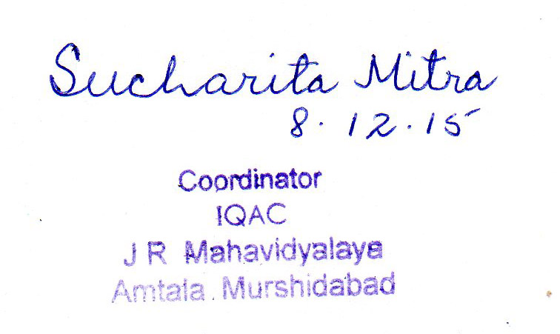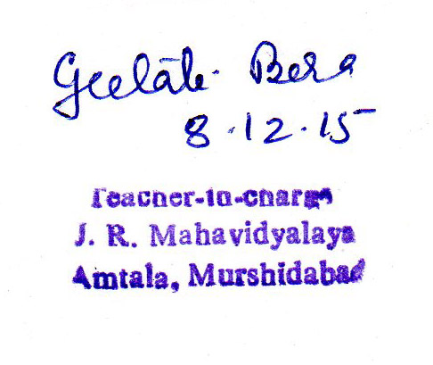
Signature of the Coordinator, IQAC Signature of the Chairperson, IQAC

_______***_______

Annexure I
Abbreviations:
CAS - Career Advanced Scheme
CAT - Common Admission Test
CBCS - Choice Based Credit System
CE - Centre for Excellence
COP - Career Oriented Programme
CPE - College with Potential for Excellence
DPE - Department with Potential for Excellence
GATE - Graduate Aptitude Test
NET - National Eligibility Test
PEI - Physical Education Institution
SAP - Special Assistance Programme
SF - Self Financing
SLET - State Level Eligibility Test
TEI - Teacher Education Institution
UPE - University with Potential Excellence
UPSC - Union Public Service Commission

***************

ANNEXURE 1
JATINDRA RAJENDRA MAHAVIDYALAYA
ESTD – 1986
P.O- Amtala, Dist – Murshidabad Pin Code – 742121
Month | Teaching days | Commencement of Classes | Exam days | Scheduled breaks & other activities
JULY | Nil | - | - | -
AUGUST | Nil |  | University Exams | Independence Day, Janmashtami, Id- ul fitre
SEPTEMBER | 21 | Ist, 2nd & 3rd year classes | Nil | Students Registration for Part I Students, Freshers Welcome.
OCTOBER | 06 | - | Nil | Gandhi Jayanti, Mahalaya, Puja Vacation
NOVEMBER | 19 | - | Nil | Annual Sports, Muharram
DECEMBER | 17 | - | Nil | College Foundation Day, College social function, Winter Recess.
JANUARY | 16 | - | Test Exams (Part III) | Students Union Election, Netaji Jayanti, Republic Day, Fateha doaz Daham
FEBRUARY | 17 | - | - | Saraswati Puja
MARCH | 13 | - | Test Exams (Part II) | Holi
APRIL | 10 | - | Test Exams (Part I) | Bengali New Year, Ambedkar Jayanti, Good Friday
MAY | Nil | - | University Exams | May Day, Rabindra Jayanti
JUNE | Nil | - | University Exams | -
ACADEMIC CALENDER 2013-2014

